Theoretical and Empirical Analysis

of Audio Feature Representations for Speech Recognition

Contents

- Dataset
- Detailed design of Features
- Analysis
- Implementation
- Results
- Project Management
- Implementation report
- References

1. Design
This project focuses on analyzing different audio feature representations used in speech recognition systems. The main objective is to compare traditional handcrafted features with modern deep learning-based representations.
The framework of the project is designed as follows:
Audio Input → Preprocessing → Feature Extraction → Classification Model → Evaluation
Three feature representations were studied:
- MFCC (Mel Frequency Cepstral Coefficients)
- FBANK (Log Mel Filter Banks)
- wav2vec 2.0 (Deep learning-based representation)
A Support Vector Machine (SVM) classifier was used as a common model across all features to ensure a fair comparison.
- Dataset Sourced From (Kaggle)
(i)Speech Commands Dataset v0.02 (Yash Dogra)
2. Dataset
The dataset used in this project is the Speech Commands dataset, which consists of short audio recordings of spoken words.
- Total samples: ~15,000
- Audio format: WAV
- Duration: ~1 second per clip
- Sampling rate: 16 kHz
- Classes used: “yes”, “no”, “up”, “down”
Each class contains multiple recordings from different speakers, providing variability in speech patterns.
For wav2vec 2.0 experiments, a subset of 800 samples was used due to computational limitations.
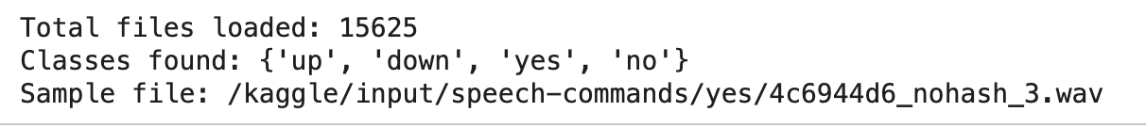
- Dataset loading output

3. Detailed Design of Features

3.1 MFCC
MFCC features simulate the human auditory system by mapping frequencies to the Mel scale. The extraction process includes:
- Fourier Transform
- Mel filter bank application
- Logarithmic scaling
- Discrete Cosine Transform (DCT)
Improvement in this project:
- 20 MFCC coefficients
- Delta and delta-delta features
- Mean and standard deviation aggregation
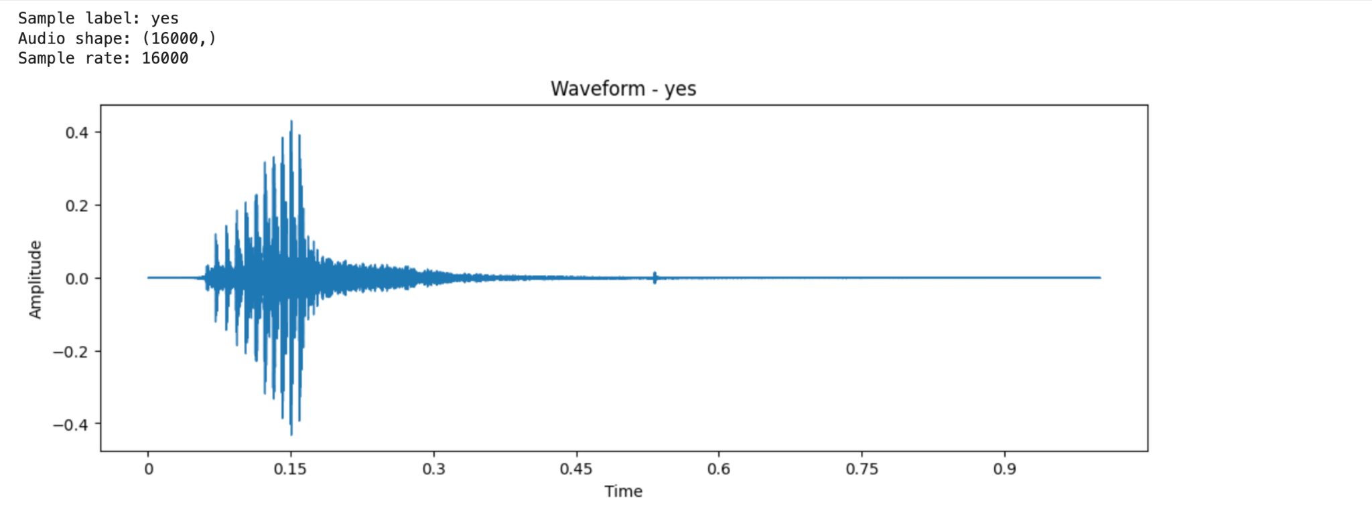
(ii) waveform plot
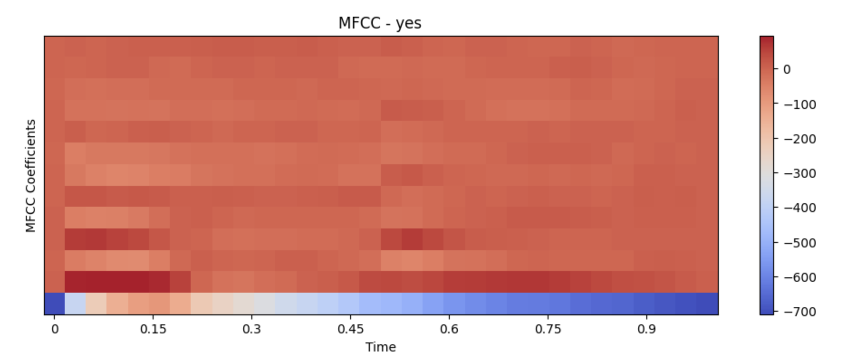
(iii) MFCC heatmap

3.2 FBANK
FBANK features are derived from the Mel spectrogram without applying DCT.
Key characteristics:
- Retains more spectral information
- Uses 64 Mel filter banks
- Captures energy distribution across frequencies

3.3 wav2vec 2.0
wav2vec 2.0 is a deep learning-based model that learns feature representations directly from raw audio using self-supervised learning.
Features:
- Transformer-based architecture
- Captures temporal dependencies
- Produces high-dimensional embeddings (768 dimensions)

4. Implementation

Preprocessing
- Silence removal using trimming
- Padding for short audio signals
- Normalization

Feature Extraction
- MFCC: extracted using librosa
- FBANK: log Mel spectrogram
- wav2vec: pretrained model from transformers library

(iv) MFCC Feature Extraction
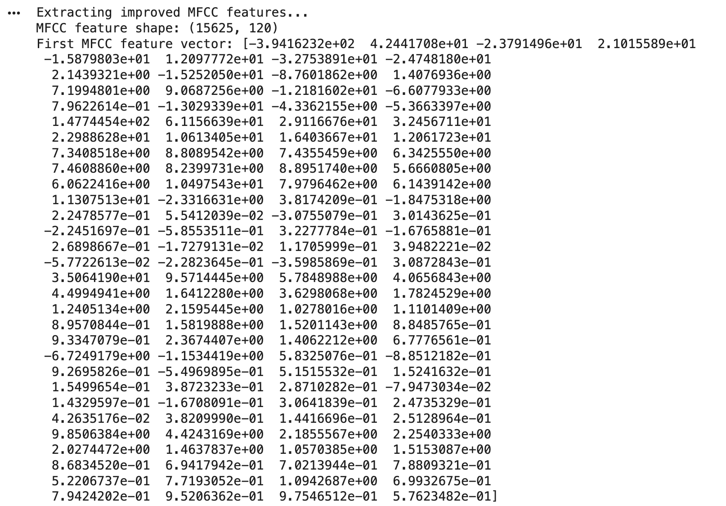
(v) Improved MFCC Feature Extraction

Model

A Support Vector Machine (SVM) classifier with:
- RBF kernel
- Feature scaling using StandardScaler

Pipeline
- Load audio files
- Extract features
- Train model
- Evaluate performance

5. Analysis
The analysis focuses on comparing:
- Accuracy of different feature representations
- Robustness under noisy conditions
- Computational efficiency
MFCC and FBANK provide strong baseline performance, while wav2vec captures deeper contextual information.
Noise analysis shows that performance decreases gradually as noise increases, indicating moderate robustness.

6. Results

MFCC Results
- Accuracy: 92.09%
The improved MFCC model achieved high accuracy due to enhanced feature extraction using delta and statistical aggregation.

FBANK Results
- Accuracy: (insert your FBANK accuracy)
FBANK features provided competitive performance due to richer spectral representation.

wav2vec 2.0 Results
- Accuracy: 94.38%
wav2vec achieved the highest accuracy, demonstrating the effectiveness of deep learning-based feature representations.

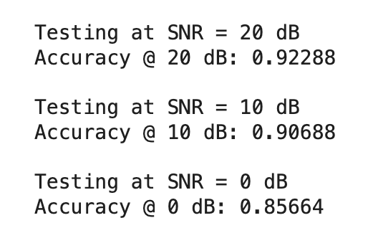

(vi)Noise Robustness

Observation:
Performance degrades gradually with increasing noise, showing moderate robustness.
7. Testing and Critical Assessment

Testing
- Model tested using train-test split (80/20)
- Evaluated using accuracy, precision, recall, and F1-score

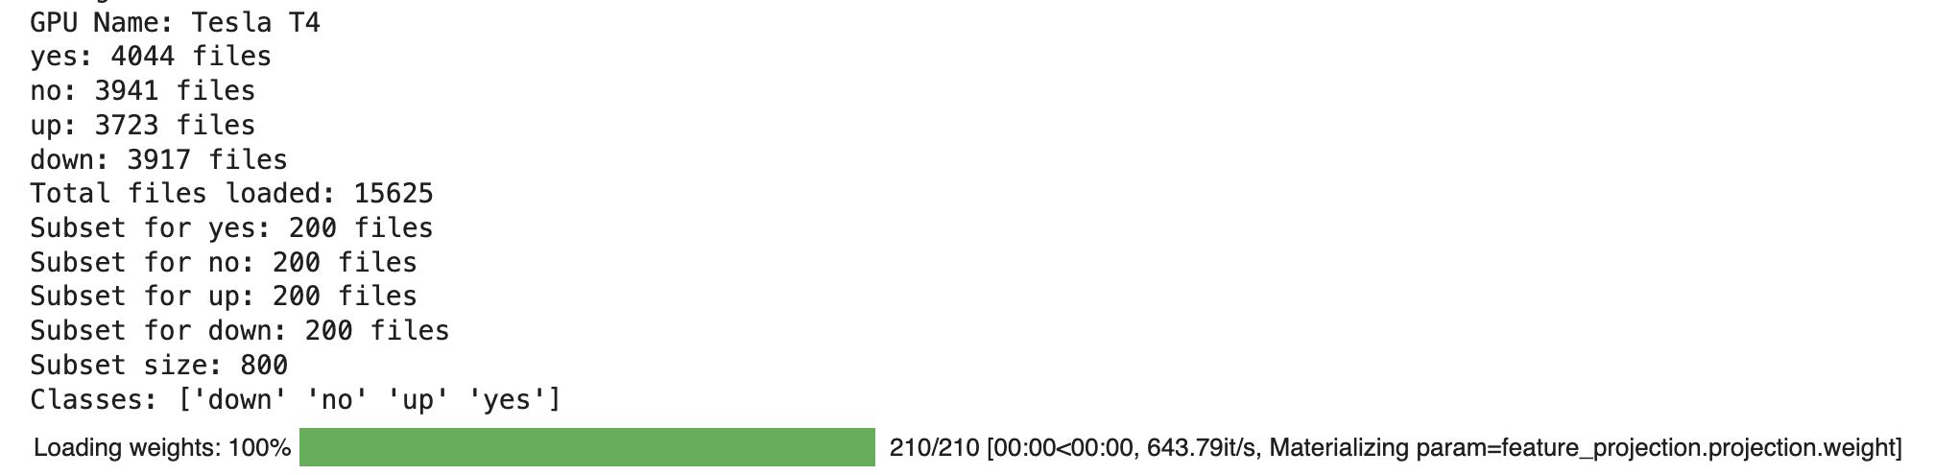

(vii) Train-Test Split

8. Deployment

MFCC is recommended for lightweight applications
- FBANK is suitable for richer spectral representation
- wav2vec is best for high-performance systems
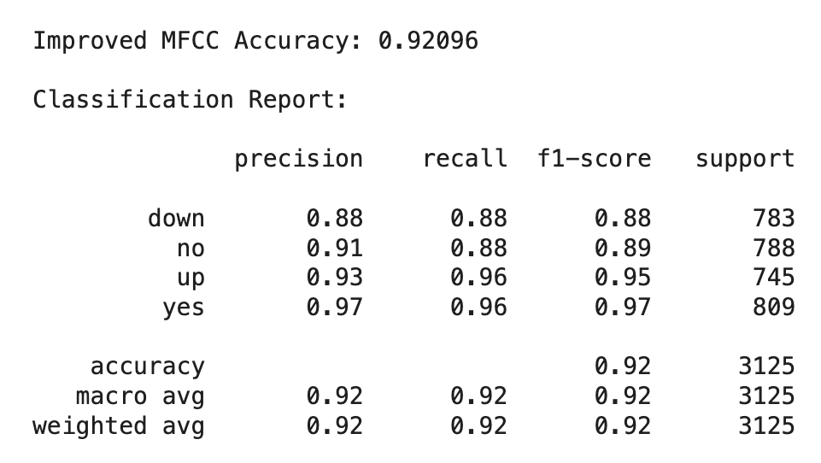
(vii) MFCC Accuracy
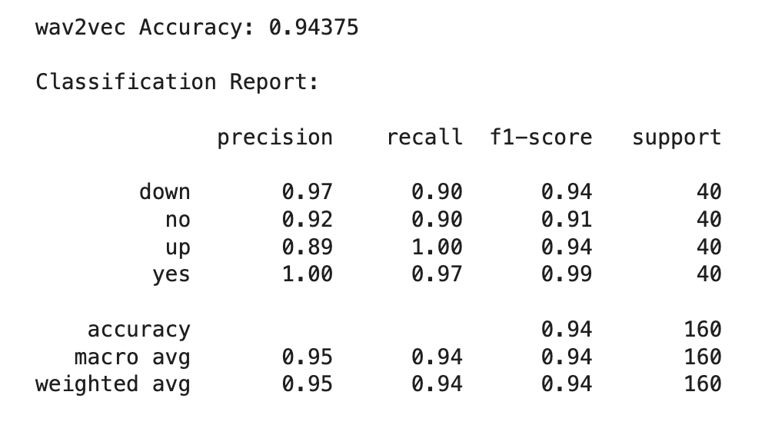
(viii) wav2vec Accuracy
9. Project Management

Implementation Report
Task | Person
Dataset preparation | SK
Feature extraction | BNR
Model training | SK,NR
Evaluation and analysis | SK
Report writing | SK

10. Description
This project compared MFCC, FBANK, and wav2vec 2.0 for speech classification. MFCC achieved strong performance (≈92%) with low computational cost, while FBANK provided comparable results with richer spectral detail. wav2vec 2.0 achieved the highest accuracy (≈94%), demonstrating the effectiveness of deep learning-based representations.
Noise analysis showed that MFCC is moderately robust, with performance decreasing gradually as noise increases.
Overall, MFCC is suitable for efficient systems, while wav2vec 2.0 is preferred for high-accuracy applications.

11. Responsibilities (Task Allocation)
Task | Person
Dataset preparation | SK
Feature extraction (MFCC, FBANK, wav2vec) | BNR
Model training (SVM, tuning) | SK, NR
Evaluation and analysis | SK
Report writing and documentation | SK

12. Contributions
Member | Contribution
SK | 50%
BNR | 50%

13. References
IEEE Format
- Davis & Mermelstein (1980) — MFCC foundations
- Baevski et al. (2022) — wav2vec 2.0
- Mohamed et al. (2022) — Self-supervised speech representation review
- Sainath et al. (2013) — Deep CNN for LVCSR
- Furui (1981) — Cepstral analysis for speaker verification

Members of the Team
- Sajitha Konda (700782694)
- ByReddy Nishitha Reddy (700782272)

